

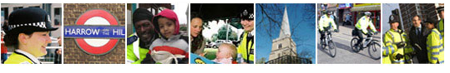

Community Safety Plan

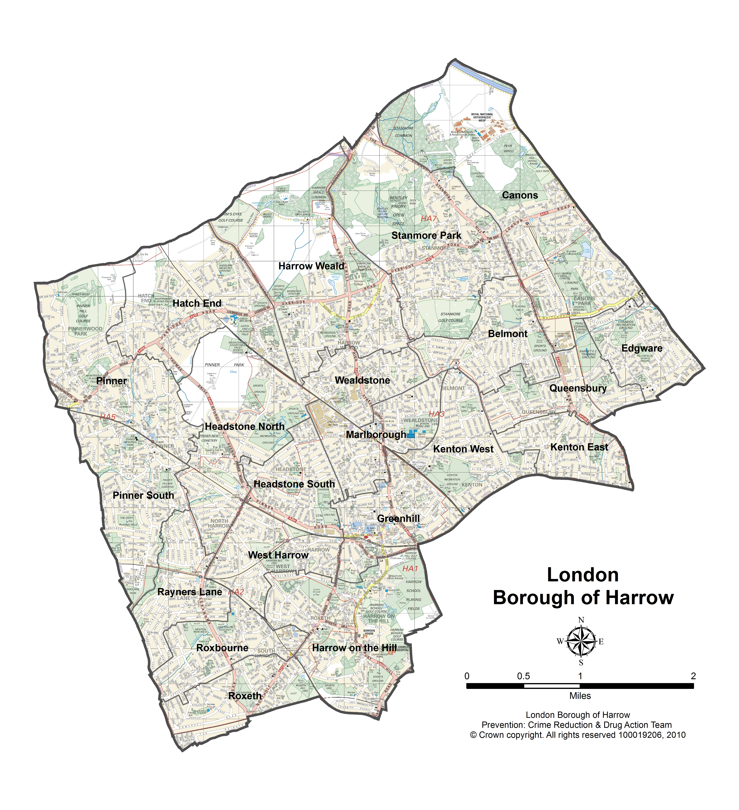
2012 – 2015

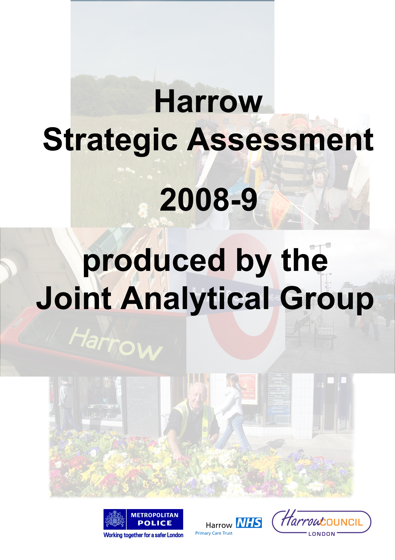




Foreword by Borough Commander; Chief Executive and Portfolio Holder for Environment and Community Safety

Welcome to Harrow’s Community Safety Plan covering the three years 2012/13 to 2015/16.

In contrast to previous Community Safety Plans, which have concentrated mainly on reducing crime, disorder and anti-social behaviour, this Plan has widened its horizons to include, alongside crime reduction, other aspects of safety including safeguarding vulnerable adults and young people, addressing domestic violence, hate crime and community tensions and helping people recover from abuse of drugs and/or alcohol.

In the last twelve months, significant progress on joint working has been achieved with the operational launch of the Multi-Agency Safeguarding Hub (MASH) which uses the data of all relevant organisations to help make the right decisions about keeping children safe and trials are now taking place to extend the MASH to cover vulnerable adults. We have also launched an Integrated Offender Management Scheme (IOM) to help ex-offenders at risk of committing further crime to instead find a home, work or training and support to stay out of trouble. Both of these schemes have the potential significantly to reduce harm to individuals and the community. We have also launched a 24 hour helpline for victims of hate crime with Stop Hate UK. Stop Hate UK provide an accessible and independent reporting and support service for victims of hate crime

As well as these specific schemes, community safety continues to be achieved through joint working, sharing information and data and organisations co-operating to achieve common goals. While each partner has their own immediate priorities, these combine to achieve increasing safety in Harrow.

This Community Safety Plan is also the first to be written with an elected Commissioner for Policing and Crime in place. In London, this role has been added to the responsibilities of the Mayor of London. The Commissioner’s powers are not very different from those that the Mayor and the GLA undertook as the Metropolitan Police Authority and it is as yet too soon to identify any changes in strategic direction. However, during the next year, the Mayor’s Office for Policing and Crime (MOPC) will develop its own voice and priorities which will influence local policing priorities and style.

Policing in London in the summer of 2012 will take on the additional responsibility of managing safety in London during the Olympics and Para Olympics, including amongst the anticipated surge of visitors to the Capital.

Community Safety is about:

Police action to detect and arrest offenders, to deter crime, to give advice and share information to keep people and property safe and to reassure communities that their safety concerns are addressed,

Council action to safeguard vulnerable people – children, young people and adults, to provide activities that engage young people and divert them from crime and anti-social behaviour to reduce offending and re-offending, to keep the Borough clean and tidy, to operate public CCTV, to intervene to reduce anti-social behaviour, to reduce domestic and sexual violence and to reduce hate crime and community tensions;

Probation action to protect the public by supervising offenders in the community and to reduce re-offending, and to lead on the operation of the Integrated Offender Management scheme

NHS action to provide substance misuse education and treatment services, and mental health services;

Fire Brigade action to help people stay safe from fire and other emergencies, in the home, at work and in London’s other buildings, to respond to emergencies, to make sure London is prepared for a major incident or emergency; and to take urgent enforcement action when we believe public safety is being put at risk in buildings;

Voluntary and Community Sector action to support individuals at risk of offending, communities at risk of crime and anti-social behaviour and victims; and

Individual action to become a Neighbourhood Champion, to take responsibility for your own behaviour and actions, to report crime and anti-social behaviour and to support each other if threatened by crime.

As this range of activity shows, community safety is a complex series of issues that cannot be successfully tackled by any agency working alone so representatives of all of the groups listed meet together as the Safer Harrow group to plan how best to reduce crime and anti-social behaviour. Our ideas and actions for 2012/13 and the two years beyond are set out in this plan.



Dal Babu Michael Lockwood Councillor Phillip O’Dell
Borough Commander, Chief Executive Portfolio Holder, Environment and
Harrow Police Harrow Council Community Safety
Harrow Council

Contents

Introduction 5

Purpose of the Plan 5

Nature of Safer Harrow 5

Funding 7

Strategic Assessment 8

Case Studies 13

Priorities for 2012/13 14

Consultation 14

Confidence Survey Results 16

Action to address priorities 18

Other aspects of community safety 22

Future of Safer Harrow Council 27

How the plan will be monitored 27

Introduction

Early in each new calendar year, the Police and the Council review the crime figures for the previous 12 months and assess which crime types are of most concern. The findings are brought together in a Strategic Assessment and are subject of consultation with the Residents’ Panel to check that the statistical data mirrors residents’ experience. The Community Safety Plan then sets out how the partnership intends to respond to the local crime landscape. This Community Safety Plan covers the period 2012/2015 although in much more detail for 2012/13 than the later years as the plan will be refreshed each year to reflect up to date conditions.

This Plan, however, goes much further than its predecessors in taking a wide view of what constitutes community safety and extending the Plan’s remit to include Adult and Children’s safeguarding, domestic violence, hate crime and community tension monitoring and helping people recover from abuse of drugs and/or alcohol. It also includes several case studies showing the impact of action taken in the last year. In future years, the Plan will continue to expand to include public health messages which contribute to personal and community safety and well-being.

This Plan also sets out development areas for the Community Safety Partnership, which locally is called Safer Harrow, to ensure it remains a strong and sustainable partnership with a strategic focus and effective performance management. It also looks at the developing relationship between Safer Harrow and the Health and Wellbeing Board, which is also a partnership body, concerned primarily with health and social care abut also with other services that contribute to wellbeing. Community Safety in its widest sense is a key component of wellbeing.

Purpose of the Safer Communities Plan

This Plan describes the work of the Council, the Police and partner agencies to reduce crime and create safer and stronger communities across Harrow by:

- Identifying priority community safety issues and geographical areas based on our strategic assessment;
- Working in partnership with other organisations to keep the Borough clean, green and safe;
- Supporting and protecting people who are most in need;
- Communicating with and involving people in Harrow to address the issues that matter most to them;
- Mainstreaming community safety activity within the Council’s service plans and those of partner agencies; and
- Leading and supporting Safer Harrow in delivering safer communities.

The nature and future of Safer Harrow

What is Safer Harrow?

Safer Harrow is the name of the Community Safety Partnership that was set up following the 1998 Crime and Disorder Act. Partnership approaches are largely built on the premise that no single agency can deal with, or be responsible for dealing with, complex community safety and crime problems and for improving wellbeing and that success will only come through joint working.

The Partnership comprises:

- Harrow Police
- Harrow Council
- Harrow Probation
- Voluntary and Community sector organisations
- Harrow Fire Service
- NHS Harrow
- The Mayor’s office for Policing and Crime (MOPC)
- A representative of Brent and Harrow Magistrates’ Court

Partners bring different skills and services to Safer Harrow. The police and the probation service, who both have as their core role the reduction of crime and disorder, play a very active role in Safer Harrow while for other partners, the crime and anti-social behaviour aspects of community safety are less central issues compared with safeguarding and wellbeing. However, all contributions are important and the range of different contributors to improving community safety in Harrow means that extensive coordination is needed. This is reflected in number and specialisation of the co-ordination and strategy groups through which Safer Harrow addresses its concerns.

In terms of formal structure or governance, Safer Harrow comprises a number of forums that facilitate coordination and delivery.

- At a strategic level, community safety is coordinated by the Safer Harrow, which includes senior managers from the partner agencies and meets quarterly;
- At an operational level, a high level body called the Joint Agency Tasking and Coordinating Group (JATCG) meets monthly to discuss operational issues that are persistent, topical or impact on large numbers of residents.
- The Anti-Social Behaviour Action Group (ASBAG) meets monthly to tackle lower level anti-social behaviour problems of individuals or of particular areas.
- The Early Intervention Panel (EIP) commissions interventions with individuals that are designed to prevent entry into the criminal justice system.
- Integrated Offender Management (IOM) is a process which brings together most of the Safer Harrow agencies to support those at risk of re-offending to stay out of trouble;
- Multi-Agency Public Protection Arrangements (MAPPA) targets the most serious sexual and violent offenders and comprises Police, Probation and the Prison Service.
- The Drug Action Team (DAT) commissions treatment, education and preventative services for people with substance misuse problems
- The Multi Agency Risk Assessment Committee (MARAC) co-ordinates work to address repeat victimisation from domestic violence
- Domestic Violence Forum – partnership group for practitioners
- Hate Crime. and Community Tension Monitoring Forum meets every two months and is a partnership forum composed of representatives from the community and voluntary sector, police, and council departments
- Harrow Hate Crime Advisory Group (HHCAG) works to increase the transparency and accountability of the police and council in their investigation of hate crime and promote confidence and resilience in the overall service
- Harrow Hate Incidents Panel (HHIP) works to reduce repeat victimisation and ensure the best possible outcome for victims and witnesses
- The Multi-Agency Safeguarding Hub (MASH) is operational everyday to respond immediately to reports of potential harm to vulnerable young people and, it is hoped, adults.
- A number of other agencies have a duty to cooperate including Children’s Services and the Youth Offending Team

The Health and Wellbeing Board has similar status to Safer Harrow and has direct responsibility for developing a Health and Wellbeing Strategy that guides the commissioning of health and social care services, including a range of activities that also support the ambitions of Safer Harrow. Working arrangements between the two organisations are being developed to make sure that the objectives and programmes of both are complementary.

These formal groups are supported by practitioner groups that share information and good practice, groups that bring the experience of victimisation or public concerns to the Partnership and regular contact between and within agencies.

Safer Harrow is only able to influence certain community safety and criminal justice services that are delivered locally. Prisons and courts for example, are managed and administered centrally.

Financial savings from partnership interventions will often not return to organisation making the investment and sometimes not to organisations within the partnership at all such as the Prison Service and Courts Service who can benefit financially from Safer Harrow’s interventions.

Funding

The Government’s public sector spending plans involve significant reductions in funding for all the agencies involved in criminal justice over the next three years. How these reductions will impact on the ability of individual agencies to support the community safety agenda will only be known as detailed budgets are drawn up year by year. However, for the current year, some examples of the decisions already made give an indication of the impact that changes to funding will have.

For the Police,
- The overtime budget for Harrow has been reduced from £495,000 to £428,000 for the policing year 2012/13 a reduction of 14.6%.
- Working with the LA we have identified LAA money from historical projects which was not spent and we are seeking to effectively use these funds for local initiatives.
- We have submitted an application to MOPAC to secure the £50,000 Community Safety Fund with an additional application seeking to spend £18,000 carried over from last year.
The Council has made significant savings in recent years. In the period 2007/08 to 2009/10 these totalled £38m. As part of the budget approved last year, £19m of savings were identified for 2011-12 with a further £12.3m for future years. Over the three years of the Medium Term Financial Strategy now proposed, an additional £18.6m of savings has been identified.

Making savings on this scale is extremely challenging, but Directors have focussed on ensuring that further changes to service delivery models are innovative, robust and deliverable and minimise the risk to vulnerable people or service failure. The extent of the cuts to public sector spending and the Government’s agenda for public service reform mean that the Council is thinking about its future shape and size; how we deliver services in collaboration more with partners and residents and bring about a new relationship that has the potential to unlock major savings.

The NHS nationally has a cash budget increase of 0.1% but has a target to save £20bn over the next 4 years. Locally, the Primary Care Trust has a deficit which requires compensatory spending reductions of 15% in all services.

The budgets of the Police, Probation and Fire Services are focused exclusively on community safety work. In addition, significant mainstream resources from Harrow Council, and the Primary Care Trust, contribute towards reducing offending behaviour in the borough

For the fire service, the Mayor’s budget targets indicate that total savings of £64.8 million will need to be made over 2013/14 and 2014/15. The London Fire Brigade (LFB) is the early stages of preparing the fifth London Safety Plan which is the main mechanism the LFB uses to make changes to the way the fire and rescue service is organised in London. The Plan will set out priorities and how services will be delivered from April 2013. The Plan will be subject to public consultation from November 2012.

Strategic Assessment

The Strategic Assessment is produced by Safer Harrow. It summarises the crime and disorder which took place in Harrow between October 2010 and September 2011.

The purpose of the Strategic Assessment is to increase understanding of crime and disorder issues in the borough and to inform decision making around how they should be addressed. As a high level summary, the Strategic Assessment does not discuss any crime or disorder type in detail, but serves to highlight the salient issues and trends. It also sets out a series of recommendations for action. More detailed analysis is regularly undertaken by the Partnership and is used to inform action and to evaluate interventions.

In June 2011, the Home Office removed many of the regulations on many aspects of Community Safety Partnerships (these are the statutory multi-agency bodies set up to tackle crime and anti-social behaviour). It is no longer a statutory requirement to produce a Strategic Assessment. However, it was felt that a summary of crime and anti-social behaviour in Harrow would be help the Partnership identify Harrow’s identify key problems and set priorities.

Level of total crime in Harrow, neighbouring boroughs and London

A total of 13,999 crimes (often referred to as total notifiable offences (TNO)) were recorded in Harrow in 2011. This is the fifth lowest total of London’s 32 Metropolitan Police boroughs. Once the population size of the boroughs is taken into account, Harrow’s crime rate of 61 crimes per 1000 population puts it second lowest with only to Bexley, which recorded 55 crimes per 1000 population, with a lower crime rate. The borough with the highest level of crime in London, was Westminster, but as Westminster has unique characteristics as a leisure, transport and business hub, its rate of over 300 crimes per 1,000 populations it is not typical or directly comparable. Camden recorded the second highest crime rate with 171 crimes per 1,000 populations.

The crime rates in Harrow’s neighbouring boroughs were 108 per 1,000 population in Brent; 100 per 1,000 population in Ealing; 89 per 1,000 population in Ealing; and 78 per 1,000 population in Barnet.

Change in level of crime in Harrow, neighbouring boroughs and London

The total number of crimes in Harrow fell by 9% in 2011 compared to 2010, this compares to a 1% reduction in London as a whole. This is the third largest reduction of London’s 32 Metropolitan Police boroughs. Only Bexley (14%) and Newham (9%) recorded larger reductions.

Three out of four of Harrow’s neighbouring boroughs recorded an increase in the level of crime in 2011. Hillingdon and Barnet both recorded moderate increases, Brent recorded a 6% increase and Ealing recorded a 6% reduction.

What crimes and ASB have gone up?

While, there was a 9% reduction in overall crime in 2011, several categories of crime showed increases during 2011:

- Personal robbery increased from 423 to 587 (39%).
- Residential burglary increased from 1744 to 1988 (14%). The most recent figures indicate the residential burglary is starting to decrease
- Theft of cycles increased by 24%
- The number of gun crime offences increases by 5%
- Knife crime increased by16% (196 offences between April 2011 to February 2012)
- Serious youth violence increased by 12% in the financial year to date to February 2012 compared to the previous period up February 2011. It should be noted that the level of serious youth violence in Harrow is still one of the lowest of London boroughs.

What crimes have gone down?

While attention and resources are more likely to be directed to crime types that have gone up, it is interesting and useful to see which crime types fell in 2011

- Violence against the person fell by 16%; this includes all major assault categories (common assault to wounding) and harassment. There were also no murders. (Only three other London boroughs recorded no murders in 2011. Brent, Ealing and Barnet recorded four to five murders each)
- Rape fell from 63 to 57 offences (10%) and domestic violence by 8% to 1,161 offences
- Theft of a vehicle fell by 10% and theft from a vehicle by 17%
- Theft from shops fell by 24%
- Overall criminal damage fell by 12% - including all major type of criminal damage
- Racist and religious hate crime fell by 28%

Where crime and ASB takes place

Every part of the borough is impacted on by crime in some way, but there are several areas where there are higher concentrations of crime. These areas are often referred to as ‘hotspots’. Four of these key hotspots are briefly discussed below.

Harrow Town Centre/Greenhill Ward

With 1707 recorded offences in 2011, Greenhill Ward continues to have the highest crime of any of Harrow’s 21 wards. As well as being an area of heavy footfall, which in itself is likely to be associated with a higher volume of crime, there are three notable crime generators:

- a cluster of bars and pubs associated with violent crime in the late evenings and weekends
- a heavy concentration of retail outlets associated with theft related offences in mornings and afternoon
- a major transport hub associated with ASB and other offences

The level of crime in Greenhill ward has decreased drastically in recent years. Overall the number of offences in Greenhill ward fell by 358 (18%) in 2011. This is well over one quarter of the total reduction in crime in Harrow in 2011. Since 2008, crime in Greenhill ward has fallen by 28%.

In terms of changes in the number of specific crime types in 2011

- Violence against the person, including all assaults, fell by 102 offences (23%)
- the number of personal robbery offences increased from 57 to 68 offences
- Residential burglary decreased by one offence to 144
- Theft from shops fell from 326 to 216 offences (34%)
- Criminal damager fell from 137 to 111 offences (19%)

Much of the reduction in offending levels in Greenhill ward and the Town Centre is likely to be due to various partnership interventions, in particular the Town Centre Team and the Safer Transport Team.

Wealdstone Corridor

This area covers the areas around George Gange Way in the west of Marlborough Ward and continues north into the High Street in Wealdstone Ward. High levels of crime are recorded in both these wards. This area has been associated with youth violence including a group of young people associated with a gang. Crime in Wealdstone Ward fell by 10% and in Marlborough Ward by 14% in 2011.

However, crime in Marlborough ward increased in 2009 and 2010, making the number of crimes in 2011 (904 offences) higher than the 808 offences recorded in 2008. There was a substantial drop in theft from vehicle offences in Marlborough in 2011, from 192 offences in 2010 to 64 offences in 2011. Conversely, personal robbery increased in Marlborough from 25 offences in 2010 to 56 offences in 2011. There was a similar pattern in Wealdstone Ward with a substantial decrease in theft from vehicle offences and an increase in personal robbery. Relatively high levels of serious violence are also recorded in these wards. There were 33 wounding offences in 2011.

Edgware

Edgware experienced the sixth highest level of crime of Harrow’s 21 wards in 2011. This ward also experiences the highest levels of environmental crime in the borough such as fly-tipping and litter. These low level problems can contribute to a lack of commitment to an area and a careless attitude to keeping the area tidy and can contribute to low level offending.

South Harrow

South Harrow straddles three wards: Harrow on the Hill, Roxeth and Roxbourne. Some of the crime and disorder problems around South Harrow are associated with young people hanging around after school and later on in the evening. South Harrow is also a major transport hub, with a busy underground station and 10 bus routes that pass through.

There has also been an increase in the spread of hate offences in the South Harrow area in 2011/2012. There are two clusters in South Harrow. The first is to the west of the junction between Northolt Road and Roxeth Hill, around the Grange Farm Estate. The second cluster is the area to the West and South of South Harrow offences took place between the Rayners Lane Estate and Eastcote Lane Estate as well as around Northolt Road

Who commits crime and ASB in Harrow?

Crime is committed by a variety of types of people in Harrow, but some groups are more likely to offend than others. For most crime types, offenders are disproportionately young and disproportionately male. White residents are the ethnic group most likely to offend, but once that group’s size in relation to the borough population is taken into account, their offending levels are approximately proportionate. I n relation to their number in the population, Asians have low rates of offending and Black residents higher rates of offending. However, the profile of offender varies considerably between crime types, with, for example, robbers tending to be much younger than burglars.

Victims of crime in Harrow

Victims are more demographically varied than offenders in terms of age, ethnicity and gender. Younger people are more likely to be victims than older people, but the relationship between age and risk of victimisation is relatively weak. Males and females have similar levels of victimisation, but these vary between offence types, with, for example, males more likely to be victims of violence in general, but females more likely to be victims of domestic violence.
Summary of Harrow’s crime and disorder problems
Performance: 2007/08 – 2010/11

The table below summarises changes in the level of crime and other criminal justice indicators from 2007/08 to 2011/12.

Crime and anti-social behaviour indicators

Crime/ASB type | 2007/08 | 2010/11 | 2011/12 | Change 10/11 to 11/12 | Change 07/08 to 11/12
Total crime | 14074 | 14968 | 14112 | -856 | 38
Common assault | 660 | 832 | 652 | -180 | -8
Personal robbery | 469 | 398 | 668 | 270 | 199
Residential burglary | 1541 | 1798 | 2080 | 282 | 349
Theft from vehicle | 1768 | 1637 | 1590 | -47 | -178
Theft of  vehicle | 548 | 364 | 331 | -33 | -217
Snatch and pickpocket | 537 | 499 | 311 | -188 | -226
Criminal damage |  | 1569 | 1476 | -93 | n/a
Young first time entrants | 164 | 86 | 92 | 6 | -72
Offences committed by young people | 564 | 515 | 380 | -135 | -184
Problem drug users in treatment | 391 | 387 | 418 | 31 | 27
Incidents recorded on buses | 1346 | 911 | 975 | 64 | -371
Racist offences | 117 | 227 | 195 | -32 | 78
Domestic violence | 920 | 1270 | 1144 | -126 | 224
Incidents on trains and tubes | 781 | 491 | 370 | -121 | -411

In 2011/12, there were 14,112 crimes in Harrow (officially referred as total notifiable offences (TNOs)) compared to 14,986 offences in 2010/11, a decrease of 5.7%.

Recent performance and trends
The Police set targets for reductions in particular crime types and also targets for the rate for resolving those crimes. Resolving is measured by the Sanction Detection rate which means the number of offences for which a judicial outcome is achieved such as a conviction or a caution.

Fire Service Performance

The Fire Service’s priority is to make people safer in their homes and within their communities. By actively engaging with London’s communities they are able to inform and educate people in how to reduce the risk of fires and other emergencies. The Service believes that by empowering individuals with knowledge and skills regarding; preventing, detecting, and escaping from fire, they will make informed choices and decisions which will improve the safety of themselves, those they live with, and others in their community.
While the Service wants to make everyone in London safer, their analysis shows that some people are more vulnerable to fire risks than others. Therefore they prioritise work to help these people first. Fires are analysed by the type of property they occur in and the cause of the fire, and from this work, fire prevention priorities are identified. The places and people who are most at risk are also identified through using a range of social, demographic and geographic data. Preventative methods are targeted most towards these higher-risk people and places.
Although there has been a significant decline in the number of fire deaths and injuries over the past decade, the Service continually strives to bring these figures down even further. To help achieve this, a range of targeted schemes and initiatives are delivered with the intention that their combined effects will bring about a greater reduction in fires, fire deaths and injuries. The main method of preventing fires in the home is home fire safety visits programme (HFSVs). These visits are targeted at those most at risk from fire and are used to provide residents with individually tailored fire safety advice and, where necessary, install a smoke alarm.

Within the 2011/2012, crews responded to 2059 incidents within the borough of Harrow. Of these 477 incidents were fires and 511 were special services such as flooding, road traffic collisions and lift releases.

Performance Indicators | 11/12 Target | 11/12 Actual | 12/13 Target
Fires in the home (Accidental) | 127 | 127 | 126
Fire in non-domestic buildings (Accidental) | 48 | 42 | 48
Fires – Rubbish (deliberate & unknown motive) | 93 | 35 | 92
False alarms from automatic systems (Non Domestic) | 539 | 553 | 530
Shut in lift releases | 36 | 41 | 38
Time spent by station staff on community safety | 10% | 13% | 11%
Home fire safety visits carried out | 781 | 946 | 817
% of Home fire safety visits to priority homes / people | 65% | 77% | 70%
1st Appliance – Average arrival time to incidents in Harrow | 6 minutes | 6:41 | 6 minutes
2nd Appliance – Average arrival time to incidents in Harrow | 8 minutes | 9:51 | 8 minutes

Case Studies

It is useful to consider the impact achieved by actions taken by the Council and the Police to address community safety concerns. It is difficult to attribute a change in the crime rate or in anti-social behaviour to a particular cause when a wide range of factors influences individuals. However, case studies can show direct outcomes of particular initiatives and give an indication of their value. The following case studies highlight two particular projects and include specific outcomes that would not have been achieved without the investment in preparing and following through with initiatives. Clearly, there are continuing outcomes from both of these projects in addition to the impact highlighted.

Action by Neighbourhood Champions

Two neighbourhood champions in adjoining streets raised a concern about a large property that had been divided up and was being rented out to a large number of individuals. Neighbours were experiencing problems of noise, disorder and had suspicions that drug dealing was taking place. These problems had been going on for an extended period.

After the input from the neighbourhood champions, an investigation took place which involved the Police and Council service teams including planning enforcement, private sector housing, anti social behaviour and environmental health. A number of enforcement actions were put in place including carrying out a Police drugs raid. The landlord was contacted and advised on implementing proper systems for controlling a property of this type.

Following the input from the services this has become a well run property with a permanent management presence. The problems which had previously been experienced have ceased, as has the disruption to the community.

Distribution of Smartwater

2010-11 and 2011-12 have seen the roll-out of a major crime reduction initiative in Harrow, the free on-demand installation of Smartwater to households in Harrow. This has seen the Police visiting approximately 30,000 homes across the borough, installing Smartwater and offering crime prevention advice and information to residents.

Smartwater allows property to be tagged with an invisible mark which can be tracked back to the individual household where it was installed. This means that if the Police find this property at a later date, they can conclusively prove that the item is stolen- and exactly where it was stolen from, making life very difficult for would-be burglars.

The impact of Smartwater on burglary trends will be evaluated in a detailed study which will be carried out in the 2012-13 year but it is already apparent that the project has had a positive impact – over the time when the home visits were being carried out, surveys have shown public confidence in the Police and Council’s crime reduction work increasing from below 30% to over 80%.

Suggested priorities for Safer Harrow in 2012/13

With limited resources to tackle crime and disorder problems, Safer Harrow inevitably has to prioritise certain offence types over others. From the analysis of crime and disorder problems in the Strategic Assessment and the performance information, the following crime and ASB types are suggested as priorities:

Residential burglary: This is a high volume crime that impacts significantly on households and communities. There were 2080 offences in 2011/12 compared to 1798 offences in 2010/11, an increase of 16%.

Robbery and Snatch: There were 668 personal robberies in 2011/12, a 68% increase on the 2010/11 figure of 398. The figures for snatch show a reduction to 311 offences in 2011/12 compared with 499 in 2010/11 a decrease of 38%. The combined figure shows a 9% increase in 2011/12 over the 2010/11 total.

Anti-social behaviour (ASB): Anti-social behaviour in this context means low level nuisance behaviour and degradation of the environment, including incidents such as fly-tipping and graffiti. Residents are far more likely to experience behaviour such as young people hanging around and graffiti than serious violent crime. ASB is also particularly suited to a local response as the problems differ considerably between geographical areas and local practitioners are likely to know more about the problems and the best solutions.

Serious youth violence: Despite an overall reduction in offending by young people, including violent offences, there are indications that serious youth violence has increased in 2011 in Harrow. Evidence for this comes from recorded police data as well as intelligence from front-line practitioners. There were 104 offences of serious youth violence in Harrow between April 2011 and February 2012, a 20% increase on the same period in 2010/11. Similarly, both Ignite and the Positive Action Team report increased levels of concern about serious youth violence in Harrow.

The full Strategic Assessment is available from the Council and is on the Council’s website.

Consultation with Harrow residents and stakeholders

Consultation takes place on what community safety issues should be prioritised and what actions should be taken to address particular issues.

As part of the Community Safety Plan, it is helpful to consult residents on what they think the priorities should be. The agencies that make up Safer Harrow engage in a variety of methods of consultation to ensure that residents’ views are reflected in what they prioritise and how they tackle crime and ASB problems.

The Residents’ Panel

The Residents’ Panel is a sample of approximately 1,200 Harrow residents aged 18 and over. The Panel is representative of the population of the Borough by ethnicity, age, religion, disability, geographical spread, employment status and housing tenure. The Panel was asked about three main issues in the spring based on the findings of the Strategic Assessment. These were:

- how safe people felt in their local area both after dark and during the day
- to what extent the Police and other public services seek people’s views about anti-social behaviour and crime; and
- to what extent people saw particular types of anti-social behaviour as a problem

In answer to the first question, 51% of respondents felt very or fairly safe outside in the local area where they live after dark and 82 % felt very of fairly safe outside in the area where they live during the day. There were variations across the Borough with the wards feeling safest in answer to both questions being Pinner and Pinner South and the wards with the lowest scores included Roxeth, Roxbourne and Wealdstone.

With regard to the second question, 58% agreed or strongly agreed that their views were sought. There were significant fewer people agreeing with the proposition in Harrow Weald

The Panel were also asked whether a range of anti-social behaviours were a big problem of not much of a problem at all. The headline results for those reporting that each type of anti-social behaviour was not much of a problem or not problem at all are shown in the following table.

There were variations in the response by ward with the moist significant being:

Type of ASB | Big or very big problem outliers | Not much or no problem outliers
Noisy neighbours | Queensbury  Wealdstone
Teenagers hanging about | Harrow on the Hill  Roxbourne  Roxeth  Wealdstone | Pinner  Pinner South
Rubbish and litter | Greenhill  Wealdstone  Roxbourne | Pinner  Pinner South
Vandalism or Graffiti | Harrow on the Hill  Roxbourne | Kenton West
Using or dealing drugs | Roxeth  Marlborough  Wealdstone
Drunk or Rowdy behaviour | Greenhill
Abandoned cars | Wealdstone

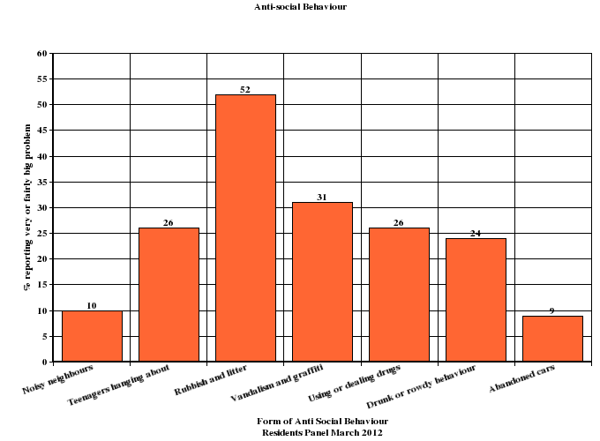

The results of the consultation are very similar overall with the response last year and do not indicate that there should be any changes to the priorities arising from the data collected for and analysed in the Strategy Assessment.

The Public Attitudes Survey

The Public Attitudes Survey, which a high quality survey commissioned by the Metropolitan Police, and produced data for each borough, suggests that the Police are concentrating on issue that matter to Harrow residents. Almost 80% of respondents thought that the Police understood issues that affect their community and 70% thought that the Police deal with things that matter to people in their community. Overall 85% of residents were satisfied

Confidence Results - Harrow
The MPS Public Attitude Survey asks residents of the following questions to measure confidence in local policing.
The results below represent Harrow resident's views.

Taking everything into account, how good a job do you think the police in this area are doing?
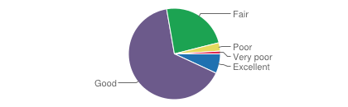
- Excellent - 7 %
- Good - 66 %
- Fair - 24 %
- Poor - 3 %
- Very poor - 1 %

To what extent do you agree that the local police are dealing with the things that matter to people in this community?
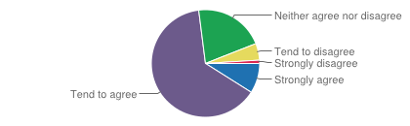
- Strongly agree - 9 %
- Agree - 64 %
- Neither agree nor disagree - 21 %
- Disagree - 5 %
- Strongly disagree - 1 %

To what extent do you agree that the police and local council are dealing with the anti-social behaviour and crime issues that matter in this area?
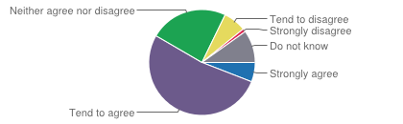
- Strongly agree - 6 %
- Tend to agree - 53 %
- Neither agree nor disagree - 24 %
- Tend to disagree - 7 %
- Strongly disagree - 1 %
- Don't know - 10 %
The PAS is representative of the population of London as a whole and is in line with census data in terms of ethnicity, age and gender. However, as with all surveys, some groups may be underrepresented. The PAS under samples White respondents aged 15-34 in some boroughs. However, the difference between the sample and the census data could, at least in part, be due to the changes that have taken place to the population of London since the census was taken.
Care must be taken when comparing the Metropolitan Police Service results with other force results, particularly as other forces are using different methodologies to capture their data.
Priorities and actions to address them

Residential Burglary

Residential burglary is theft, or attempted theft, from a residential building where access has not been authorised.

The Police and their partners intend to commit considerable resources to reducing residential burglary and other acquisitive crime over the next three years. The items outlined in this section are Partnership approaches rather than internal activities of Harrow Police, where much of the impetus for reducing residential burglary comes from.

The Partnership activities over the next three years that will impact on residential burglary and other acquisitive crime include:

- Continue the Smartwater initiative that offers free property marking to all households in the Borough that ask for it. The initiative is intended not only to deter burglary at each property at which the making system is deployed but, through mass distribution, to make Harrow an unattractive place for burglars to operate in.

- Consider funding for locks and security for victims aged over 65.

- Build on communication activities around prevention as a very high percentage of burglaries in Harrow involve obtaining access through unlocked doors and windows – and particularly those adjacent to single story extensions.

• Continue the emphasis on crime prevention by working closely with Housing and the Registered Social Landlords to make properties more secure.

• Crime reduction communication campaigns in known hotspot areas

• Provide crime prevention advice to the owners of vulnerable properties in the hotspot locations

• Continue with high-visibility Police patrols in known hotspot areas to deter offenders, as well as to gather intelligence about individuals in the area likely to be committing these offences

• Actively target known offenders and hotspot areas through pro-active operations, to reduce the number of offences

- Continue to work with other boroughs including Hertfordshire and Brent to gather intelligence about possible offenders committing burglaries in Harrow

  - Target handlers of stolen goods to restrict the sale of stolen property

Commentary

The Council and the Police have committed significant resources to the SmartWater initiative. To date, around 30,000 SmartWater kits have been installed free of charge in residential properties in the Borough. The kits have been offered to the owners of properties that have been burgled and properties near to those that have been burgled and in hot spot areas although any resident can request a kit.

The kits have not yet been in place long enough to allow a definitive judgement on the effectiveness of SmartWater deployment but further analysis will be undertaken throughout the year.

The Police recently held a multi-borough seminar to identify good practice across a number of areas including residential burglary and a number of ides in use in other parts of London are being evaluated

Robbery and Snatch

Robbery is the crime of taking or attempting to take something of value by force or threat of force or by putting the victim in fear. Snatch is taking or attempting to take something of value by applying force to the object rather than the person from whom it is taken. Snatch figures will be included in the robbery totals from now on.

Robbery and Snatch are often opportunistic crimes and can occur in any location although in Harrow, the hot spots are areas with high numbers of pedestrians, especially the Town Centre.

The age profile of both offenders and victims are broadly similar - over half the suspects are aged between 15 and 19 and the next highest age ranges are 20-24 and 10-14. Similarly, the highest number of victims come from the 15-19 age group with the 20-14 and the 10-14 year old groups next. The age of victims however, extends up through all the recorded ranges. Suspects are overwhelmingly males whereas victims are only marginally more likely to be male.

As well as high visibility patrolling, the most effective action is to reinforce community safety messages relating to robbery and snatch such as:
- Be alert and aware of your surroundings - planning your journey ahead so you know where you are going helps you to appear confident.
- If you can, avoid walking alone at night. Steer clear of shortcuts that take you through secluded or poorly lit areas such as parks and alleyways.
- If you are carrying a bag make sure clasps or main zips face inwards. Keep keys in your pocket. Never carry large amounts of cash. If confronted by a robber or snatch thief you should surrender your property without a fight - your safety is more important than your property.
- If physically attacked, shout loudly to attract attention of others and run away.
- If you suspect someone is following you, check by crossing the street - cross several times until you feel safe again. If necessary go to the nearest place where there are other people, like a shop or pub and call the police - avoid using phone boxes. This is why planning your journey is important.
- You may want to consider investing in a personal attack alarm. Make sure it is easily to hand so you can use it immediately to draw attention to yourself and hopefully scare off the attacker.
- If you are heading somewhere unfamiliar let someone know where you are going, your planned route there and when you expect to return.
- If you are going home, have your keys ready so you can let yourself in quickly.
Commentary

The proceeds of robbery and snatch tend to be cash, phones and other small electronic devices which have a ready market which is not easy to track or trace. This precludes the intelligence-led approaches that can be successful in making burglary more difficult. The new Integrated Offender management scheme may prove to be effective in targeting known robbers and burglars although it will be unable to support those living outside Harrow which applies to a significant proportion of burglars arrested here. .

Anti Social Behaviour

Many residents in Harrow experience ASB at some point. This could be fly-tipping, graffiti, litter, noise, nuisance neighbours, vandalism or youths hanging around. For some residents, levels of ASB can have a significant adverse impact on their quality of life. The partnership has a wide range of tools at its disposal for tackling ASB and intends to continue to prioritise ASB.

Some of the key partnership actions over the next three years include:

- Continue the Harrow Weeks of Action. These are multi-agency week-long events which focus on a particular area to address crime, anti-social behaviour, environmental concerns, and issues such as untaxed cars

- The tools available to the Police and Council for dealing with ASB will change following legislation in winter 2012 with the new tools in place to use in Harrow by 2013. Some of the key changes are:

- The abolition of ASBOs and other court orders and their replacement by two new tools: the Criminal Behaviour Order and the Crime Prevention Injunction
- The creation of a Community Protection Order for dealing with place specific ASB
- The creation of a single police power for dispersal around ASB
- A greater emphasis on rehabilitation and restorative justice for perpetrators of ASB

The Partnership will keep up to date with these changes and make effective use of the new tools.

- Ensure that there are effective responses to the Community Trigger (which gives victims and communities the right to require agencies to deal with persistent anti-social behaviour). This is likely to introduced in 2012

- The effectiveness with which Harrow Council deals with reports by members of the public on problems such as fly-tipping, litter and graffiti will be improved with the introduction of the Streets and Ground Maintenance Project. This new system will enable problems to be recorded more rapidly and accurately and improving how they are dealt with.

- Re-focussing the role of Neighbourhood Champions and providing greater support. It is hoped that a borough-wide conference will take place in 2011.

- Continue operations around Wealdstone where youth workers have been embedded into Safer Neighbourhood team patrols to provide a range of responses to the issues presented by young people.

- Maintain CCTV coverage in and around Harrow Town Centre. This will help to reduce ASB, a high proportion of which takes place in the Town Centre

Commentary

The ever closer working between the Council’s two anti-social behaviour teams (Environment and Housing) and the Police provides a joined up and graduated menu of responses as well as the opportunity for early intervention to try to prevent problems from escalating. The remodelling of the Safer Neighbourhood Teams to provide flexibility of deployment to the areas of most need on a daily basis and the new ‘Grip and Pace’ management arrangements introduced by the Police (and which are influencing the speed of the Council’s response to intelligence and events) all contribute to a more proactive and speedy response to anti-social behaviour.

This places the Council and the Police (as well as voluntary and community groups involved in this work) in a good position to take advantage of the new powers as and when they become available and to be able to respond to the Community Trigger provisions if they are brought into law.

Serious Youth Violence

Serious youth violence which includes GBH, knife and gun crime where the victim is younger than 20 years increased by 12% in the financial year to date to February 2012 compared to the previous period up February 2011. It should be noted that the level of serious youth violence in Harrow is still one of the lowest of London boroughs.

However, earlier this year, a number of stabbings took place between young Somali males. Chief Superintendent Babu held a number of meetings with Somali mothers, statutory and third sector partners to discuss how the mothers could help by using their influence on their children to guide them away from crime and involvement in gangs.

As a result of the meeting the 'Mothers against Gangs' was formed. Harrow police are funding the group through the Prisoner Property Act fund, and funds will be given to Harrow Association of Voluntary Organisations (HASVO) to directly fund the group.

Although MAG was set up after meetings with Somali mothers, the group will include mothers from all faiths and backgrounds.

MAG will be a self help group that will:

- Raise the profile of MAG within Harrow and elsewhere
- Assist mothers whose children are involved in or at risk of becoming involved in gangs or crime
- Assist with promoting diversionary activities for young people at risk in Harrow
- Help police and statutory partners with disseminating information within their communities

MAG will be launched at a seminar to provide mothers with information on approaches currently being trialled in Harrow and elsewhere to reduce serious youth violence and combat the influence of gangs. A number of guest speakers will provide mothers with an insight into what signs to look for to tell if your child is involved in gangs and also information of the threat to girls of joining gangs.

This work follows on from Resilience Training provided last year by the Young Foundation to help young people recognise value in social roles other than gang membership and the joint work of Safer Neighbourhood Teams and the Council’s Youth Service in addressing young people’s needs and behaviour on the street.

Commentary

Every year, there is a new cohort of young people who may be susceptible to the attraction of gang membership and may also be attracted to crime and violence. The work that has been done in the past needs to be renewed constantly to help and support the next cohort and to be developed as new thinking and approaches are developed here and elsewhere. Successes in this work are often about things that didn’t happen – reductions in the number of young people injured through violence and less reported gang activity – but it is the intention in this year to identify positive things that have been achieved by young people who have previously been in or associated with gangs as role models and, hopefully, active proponents of the benefits of change.

Other aspects of Community Safety

The priorities identified from the Strategic Assessment relate directly to the most recent patterns of crime and anti-social behaviour in Harrow. However, there is much more to Community Safety than responding to criminality. The local authority, the Health Service, the Probation Service and a wide range of voluntary and community groups contribute to improving community safety directly and indirectly.

In an attempt to recognise these contributions and to begin to develop a picture of this wider sense of community safety, the plan now looks at the specific provision made by Adults and Children’s Safeguarding, Domestic Violence support and work to address Drug and Alcohol abuse. In future Plans, we intent to widen the range of services and group s included to present a more complete account of the community safety services in Harrow.

Children’s Services
There have been massive changes in national policy and funding in the last two years. Harrow Children’s Services, however, has carried out a major piece of transformation work to ensure that it is best-placed to meet these challenges head on.

The service embarked on whole system redesign. Design children’s services now for a locality starting from a blank piece of paper would produce a design significantly different to our existing structure. Systems and processes had grown up over years to incorporate new initiatives, targets, budgets and requirements from central government as well as reacting to local needs and priorities.

A new and innovative future operating model has been developed that puts vulnerable children, young people and families firmly at the heart of a more efficient and effective system.
Staff work in multi-disciplinary Teams Around the Family. Families have rapid access to services tailored to their needs with the most vulnerable fast tracked to the help they need.

The new operating model has a single front door, staffed by an expert multi-agency team, for all early intervention and targeted children's services provided or commissioned by the council. Harrow is a Metropolitan Police pilot for a Multi-Agency Safeguarding Hub, sharing information quickly and acting together to keep children safe. Harrow is also piloting the London Safeguarding Children Board’s quality assurance framework, exploring the Reclaiming Social Work approach and training all practitioners in evidence-based programmes.

Other local areas have developed triage systems and multi-agency teams, but such a comprehensive whole system approach has yet to be delivered anywhere. These new ways of working allow professionals more time to be professionals: more face-to-face time with families and less time filling in paperwork. It cuts out unnecessary process and time wasted on complex referral systems and maximises time for direct work with children and families.

Key aspects of the Harrow model include:

- Strong partnerships with police, health and the third sector building on Total Place principles, delivering services together including a multi-agency information sharing hub
- A seamless multi-agency service with one point of contact that meets the needs of vulnerable children, young people and their families
- An early intervention approach to ensure that needs are met at the earliest opportunity and avoiding later expense once problems are entrenched
- A Team Around the Family/Child model to meet need in a co-ordinated way
- Reduced bureaucracy and improved integrated systems to maximise time that key professionals are able to work with families and share information effectively
- A new relationship between the Council and schools, acknowledging their increasing autonomy (particularly the new academies) but recognising and building on their understanding of children and family circumstances
- Maximising the efficient use of resources through robust strategic planning, commissioning and procurement of services to meet local need
- Improving outcomes through rigorous quality assurance closely linked to performance management and workforce development

This integrated operating model required a new organisational structure to bring together teams differently. The re-organisation of the Children’s Services enabled integrated working both within the local authority and with partner agencies.

Adults Services

Safeguarding Adult Services

Harrow Council and its partners totally condemn any form of abuse of vulnerable adults.

Whilst it is recognised that the vast majority of carers (paid or unpaid) provide excellent care to those they look after, it must also be acknowledged that abuse can be perpetrated by anyone. This can include paid workers or professionals (those in a position of trust), partners, family carers, relatives, friends or strangers.

In recognition of these facts, Harrow’s Local Safeguarding Adults Board (LSAB) has agreed a vision and a set of core principles and values for the Borough:

Vision

“Harrow is a place where adults at risk from harm are safe and empowered to make their own decisions and where safeguarding is everyone’s business”

Principles and Values

The Harrow LSAB partners will safeguard the welfare of adults at risk by working together (in six key areas – empowerment; protection; prevention; proportionality; partnership and accountability) to ensure that:

- there is a culture that does not tolerate abuse; (protection)
- dignity and respect are promoted so that abuse is prevented wherever possible; (prevention)
- there is active engagement with all sections of the local community so that they are well informed about safeguarding issues; (partnership)
- adults at risk are supported to safeguard themselves from harm and can report any concerns that they have; (empowerment)
- quality commissioned, regulated and accredited services are provided by staff with the appropriate level of training; (accountability)
- there is a robust outcome focused process and performance framework so that everyone undergoing safeguarding procedures receive a consistent high quality service which is underpinned by multi-agency cooperation and continuous learning; (accountability)
- victims are supported to stop the abuse continuing, access the services they need (including advocacy and victims support); (proportionality)
- there is improved access to justice; (empowerment) and
- accountability for what is done and for learning from local experience and national policy. (accountability)

The LSAB has a 3-year Business Plan which incorporates a Prevention Strategy, a Training Strategy and a Dignity Strategy and produces an Annual Report that covers the progress made on the action plan.

The LSAB recognises the key role that other main stream agencies perform as part of its wider prevention approach. For example there are joint projects with Community Safety in relation to hate crime, Trading Standards for distraction burglary, the Police in working with Banks to prevent financial abuse and Domestic Violence organisations where the victims are older people, have a learning or physical disability or a mental health problem.

Domestic violence and violence against women and girls

Following a fall of 2% in the number of domestic violence offences in 2010/11, this trend has continued with a further reduction of almost 105 in reported incidents in 2011/12. Despite this decrease, domestic violence still accounts for a higher percentage of crime in Harrow than in many other Boroughs due to the relatively low rate of other forms of offending.

Domestic Violence work includes actions under the headings of prevention; provision; partnership and perpetrators. For the purpose of this Plan, the focus is on prevention and provision which is undertaken by the Police and a range of voluntary and community organisations commissioned or supported by the Council.

Prevention

- Continue the work raising awareness of domestic and sexual violence and attitudes to violence against women and girls. A broad range of activities is covered including work in schools and community events;

- Public awareness campaigns including raising awareness addressing forced marriage and female genital mutilation;

- Specialist training for 350+ professionals in Harrow including faith, community, voluntary and statutory services.

Provision

- Mainstream funding for at least the minimum staffing levels considered necessary for Harrow of three Independent Domestic Violence Advisors (IDVAs), and a post to support the Multi-Agency Risk Assessment conference (MARAC). The IDVAs work with victims of violence to support them make choices about their future safety

- Grant funding for a part time Independent Sexual Violence Adviser;

- Continue and extend actions to maintain public awareness of DSV. A broad range of activities are included for this purpose

- Maintain the Sanctuary Scheme, refuge beds and the participation in the West London Rape Crisis Centre at least until March 2012 when the funding situation will be reviewed

Drug and alcohol misuse

The national framework around reducing drug misuse has changed significantly in the last. The Government now requires local services to

- put more responsibility on individuals to seek help and overcome dependency
- place emphasis on providing a more holistic approaches, by addressing other issues in addition to treatment to support people dependent on drugs or alcohol, such as offending, employment and housing
- aim to reduce demand and supply
- increase the role of local agencies in reducing drug misuse
- aim at recovery and abstinence.

- There is a range of drug treatment and support services available in Harrow, as detailed in the annual Adult Drug Treatment Plan.

In relation to alcohol, although this is an increasingly serious issue in Harrow as in the rest of the country, there is little specific funding made available to support education or treatment. Significant work is being undertaken to collect data to demonstrate the link between alcohol and crime and alcohol and injuries requiring treatment at an Accident and Emergency Unit.
In addition, enforcement of the existing law regarding under-age sales, the control of street drinking and the proper regulation of pubs and clubs continue to help control the damage that excess consumption can cause and the recent Government alcohol strategy which considers the case for minimum pricing may contribute to this.

Reducing re-offending

The vast majority of crime in Harrow, as elsewhere, is committed by repeat offenders. The two main agencies for reducing re-offending are London Probation: Harrow, which is the lead agency responsible for reducing re-offending and the Youth Offending Team. Both agencies try to change the behaviour of offenders and help them lead positive lives in the community.

In terms of treating offenders, Probation provides services to offenders released from prison who served a sentence of one year or more and offenders who have been sentenced in the courts to a Community Order or a Suspended Sentence Order. The Youth Offending Team attempts to prevent young offenders from re-offending.

Since the last plan, an Integrated Offender Management (IOM) scheme has been established. The scheme enjoys the support of the Probation Service; the Police; the Council; the Health Service; JobCentrePlus; the Prison Service and voluntary sector organisations.

IOM identifies individuals being released from prison who have the highest risk of re-offending based on their score against a number of factors that power the Probation OGRS system. OGRS stands for Offender Group Reconviction Scale and is a uniform national predictor of re-offending which uses static data such as age, gender and criminal history. It is used by the Probation Service, along with other systems such as OASys (Offender Assessment System) to help determine the best approach to supervision and offender management.

In the context of IOM, offenders with an OGRE score above a certain threshold are invited to take part in the scheme. The Harrow scheme can cater for a cohort of 32 offenders at any one time and these will be a mix of statutory offenders (those who received a sentence of 12 months or more) and non-statutory offenders. These are the offenders at the highest risk of reoffending although not necessarily those who might commit more serious crimes.

The benefits of taking part are that the scheme provides easier access to and guides participants through the processes of obtaining out of work benefits, employment, housing, places on substance misuse programmes or perpetrator programmes for addressing domestic violence where appropriate. In return, participants agree to a strict regime of probation supervision and police preventative interventions. For example, police and probation officers may call on IOM participants periodically and unannounced to remind them that they are of interest to these services. A breach of agreed behaviour leads to the withdrawal of the benefits of participation (although not the loss of out of work benefits or accommodation).

IOM is presented to participants as a last chance of turning their lives around and avoiding the revolving door of repeated prison sentences.

The concept of IOM has been piloted in several London Boroughs over the last two/three years with promising results. Harrow is part of a six borough Probation-led pilot employing different voluntary sector support agencies. For Harrow and Hillingdon, an organisation called P3 has been employed by the London Probation Trust. Their current offer in Harrow includes helping prisoners complete benefit application forms before their release date and meeting them at the prison gates. P3, in conjunction with the Probation Service's existing accommodation officer, tries to identify accommodation and arranges deposits, moving in and support with basis furniture where necessary. P3, again in conjunction with existing Probation provision, also seeks employment or pre-employment training courses for IOM participants.

P3's offer in Kensington and Chelsea, where the scheme is more established, includes a Hub which provides a place to go during the day if participants do not yet have a job or a course and where there is additional support in writing CVs and applications, identifying potential courses and developing interests and hobbies and socialising that together provide reasons for wanting to stay out of trouble.

P3 have use a desk adjacent to the MASH as well as use of accommodation at the Probation Service. The Police locally have offered accommodation at South Harrow Police Station for all those associated with IOM and this is currently being evaluated.

The Future of Safer Harrow

Safer Harrow is trying to join up the wide range of organisations and services that contribute to the provision of community safety in Harrow. It has added a representative of the Magistrates’ Court to its membership in the last year and will continue to seek additional partners who can add to the mix of services, experience and knowledge that can help to make sense of the complex picture of needs and service offers that currently exist, identify gaps and duplications and help to achieve the highest standards at the most affordable costs.

One of the relationship s that will need to be explored in the coming year is that with the new Health and Wellbeing Board. This Board, which is currently in shadow form, will be fully established with effect from April 2013 and will be primarily concerned with identifying the health and other services that need to be commissioned for Harrow. The wellbeing part of the Board’s responsibilities, however, includes aspects of community safety and it will be important to ensure that efforts to increase wellbeing complement work to secure community safety.

How the Plan will be implemented and monitored

The Community Safety Plan has been compiled by combining the action plans of the partner agencies. It will be submitted for adoption by Safer Harrow, the Council Cabinet and the full Council as it forms part of the Council’s policy framework.

The Plan will, however, be owned by Safer Harrow which is responsible for delivering reductions in crime and anti-social behaviour. Safer Harrow will monitor changes in both the crime rate and the sanction detections and, at the same time, progress on the projects set out in this plan. This will give oversight of the extent to which the activity that partners have undertaken to deliver has been achieved and also the impact that completed actions and projects make on the incidence of crime and anti-social behaviour.

As well as quarterly monitoring at safer Harrow meetings, there will be an annual review of the Plan and whether the outline actions included for later years are still appropriate and should be worked up in greater detail. This will lead to updating the action plan for 2012/13 and 2013/14. Unless the updating results in seeking new strategic objectives, it is not necessary for further formal approval to be obtained from Cabinet or the Council.

This plan should be sufficiently robust to absorb the changes envisaged by Government in the administration of criminal justice as these have been foreshadowed in drafting this document. The risks facing the plan are to be found more in the impact of continuing reductions in resources rather than legislative or organisational changes and is a possibility of requiring an interim plan next year or the year after if there are no longer resources to enable Safer Harrow to fulfil its obligations.

As well as the strategic overview brought to crime and anti-social behaviour by Safer Harrow, the various sub-groups and specialist groups will be responsible for monitoring their own action plans and the results that those strategies achieve and reporting these to Safer Harrow. Safer Harrow will therefore be well placed to identify the efforts made and the effect achieved of community safety activity.

